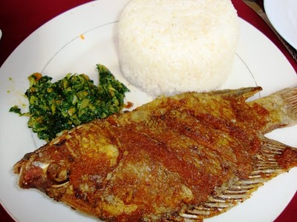

**Samaki wa kukaanga**

Ingredients:

Fish fillets, cut into serving portions — 2 pounds

* Lime or lemon juice — 1/4 cup
* Garlic, minced — 4-5 cloves
* Salt — 2 teaspoons
* Cayenne pepper — 1/4 to 1/2 teaspoon
* Oil — 1/2 cup

Method:

1. Add the fish, lime or lemon juice, garlic, salt and cayenne pepper to a large, non-reactive bowl and set aside to marinate for 20-30 minutes.
2. Heat the oil in a saute pan or skillet over medium-high heat.
3. Remove the fish fillets from the marinade and pat dry with paper towels.
4. Fry the fillets in the hot oil until browned on each side.
5. Serve with rice and sukuma wiki.

Enjoy